Stakeholder Report

Executive Summary

This project analyzed construction simulation data to uncover meaningful project groups and use them to improve prediction of Simulation Accuracy. Clustering revealed three types of projects, and adding these groups as features improved supervised regression models. These findings show that recognizing project types can help construction teams plan more effectively and predict project performance with greater accuracy.

Feature Discovery
The dataset contained information on temperature, humidity, vibration, material usage, energy consumption, worker count, task progress, safety incidents, and risk score. Exploratory analysis showed wide variation across these features, and the correlation heat map confirmed that no single feature strongly drove performance. This made the dataset suitable for unsupervised learning. KMeans clustering was used after standardizing numeric features. The elbow method and silhouette scores supported choosing three clusters. A PCA plot showed partial separation between the clusters.
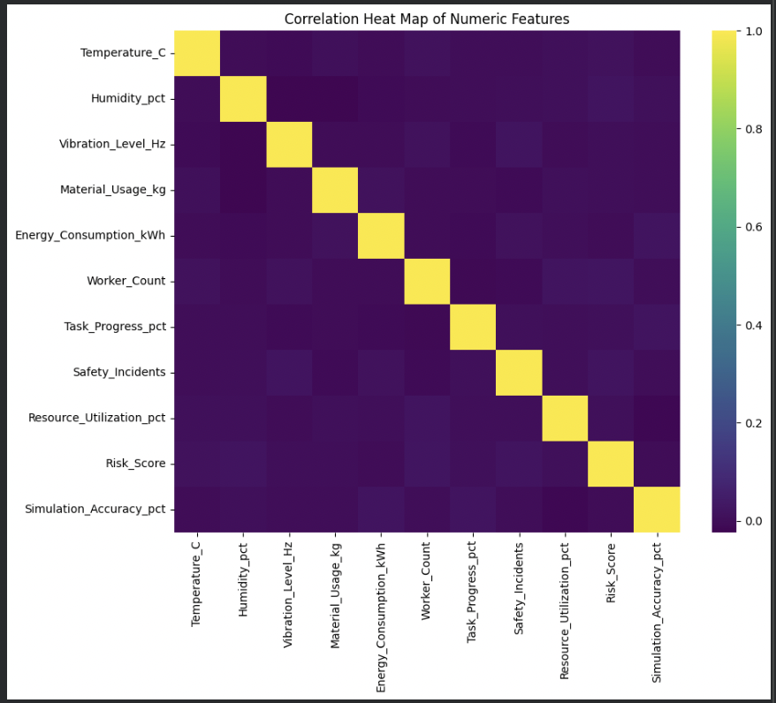
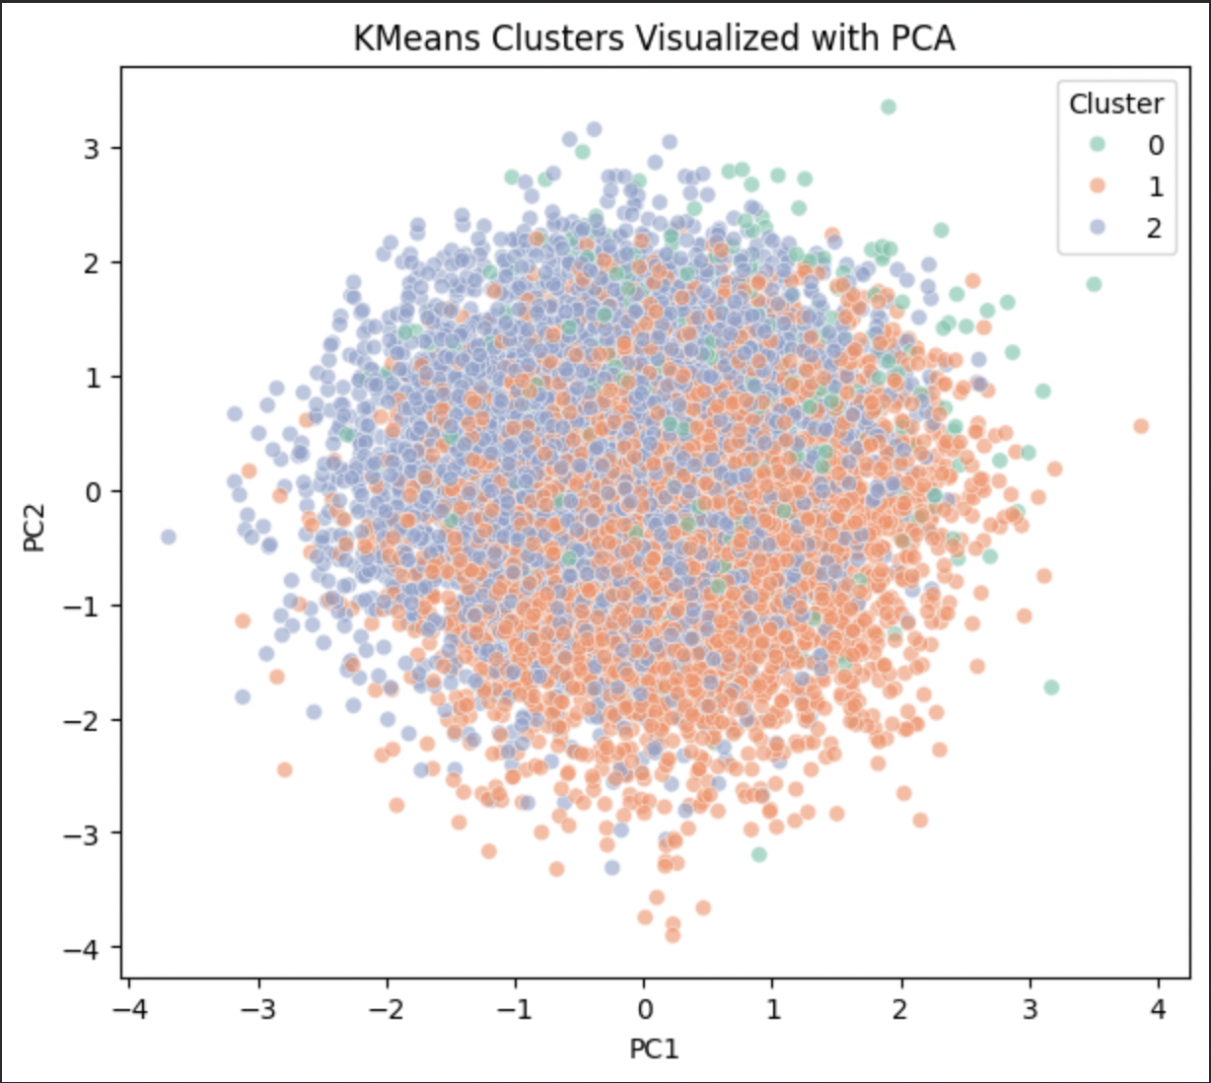
The cluster profile table helped describe the groups.
Cluster 0: Typical Projects
Average values for most features and balanced performance. These reflect common working conditions.
Cluster 1: Heavy Resource Projects
Higher temperatures, higher material usage, and larger worker counts. These projects operate with greater demand on resources.
Cluster 2: Efficient Low Temperature Projects
Lower temperatures and slightly lower material usage while maintaining steady performance. These projects appear more efficient.
These groups summarize overall project behavior and provide a clearer picture of site conditions than examining variables separately.

Predictive Models
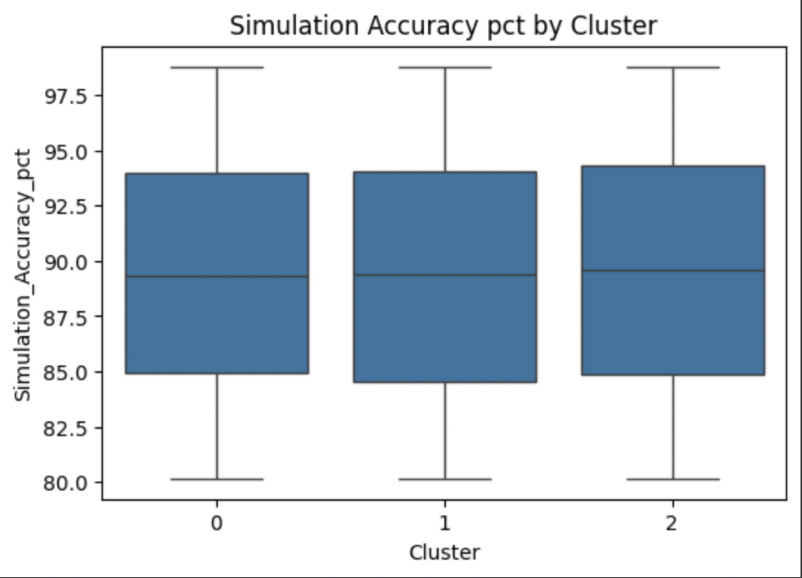
To test whether the clusters added value, I built three regression models: linear regression, decision tree regression, and random forest regression. Each model was trained once with the original features and again with the cluster label added. Even though the Simulation Accuracy box plots for the clusters look similar, the models still performed better when the cluster label was included. This means the clusters captured patterns in the broader feature set that helped the models estimate Simulation Accuracy more effectively.
Business Recommendations
Classify projects early.
Identifying the project type at the start helps anticipate conditions, staffing needs, and material requirements.
Prepare for heavier demands in Cluster 1 projects.
These projects use more resources and larger teams, so planning ahead reduces delays.
Learn from Cluster 2 projects.
Their steady performance with lower material use can guide efficiency improvements.
Use predictive models during planning.
Adding prediction tools to simulations helps teams make earlier and better informed decisions.

Limitations and Next Steps
The data comes from simulations rather than real field measurements. Testing the models on actual construction projects would help confirm their value. Some variables did not differ much across clusters, which suggests that adding more operational detail could strengthen future analyses. Additional clustering methods or advanced models could also be tested.

Conclusion
Clustering revealed meaningful project types, and adding these types to prediction models improved their performance. These insights can help teams plan resources, anticipate challenges, and forecast project outcomes with greater confidence.

